We are pleased to continue offering our support to Parents Consortium Parents Consortium, a local charity that supports disabled children and their families.

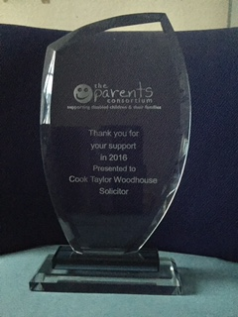

The disabled children and young people who access their services will typically have one or multiple learning difficulties, complex health needs, physical or sensory impairment, challenging behaviour, Autism or severe ADHD.

The Charity’s work is divided up into four key areas. These are Short Breaks Services, Family Advice Service, Direct Payment Service and Dragon’s Retreat Short Break Unit.

Parents Consortium needs to raise £1.4 million in order to continue their care services. Their funding comes through grants, donations, charitable giving and a supporting community/business sector working alongside Kent County Council Social Services

http://parentsconsortium.org.uk/

